

FURTHER MATHEMATICS
TRIAL EXAMINATION 1
2003
SOLUTIONS

_____________________________________________________________________

Section A Section B – answers
-answers

Core Module 1 Module 2 Module 3 Module 4 Module 5

1. B Arithmetic Geometry Graphs Business Networks
2. D and and and related and
3. C applications trigonometry relations mathematics decision
4. A maths
5. E 1. A 1. D 1. C 1. A 1. C
6. A 2. E 2. C 2. C 2. C 2. D
7. D 3. C 3. D 3. E 3. B 3. C
8. B 4. B 4. E 4. C 4. B 4. E
9. B 5. D 5. A 5. A 5. A 5. B
10. C 6. C 6. B 6. A 6. E 6. B
11. B 7. B 7. E 7. B 7. C 7. C
12. E 8. C 8. A 8. D 8. A 8. E
13. D 9. B 9. D 9. D 9. A 9. E
___________________________________________________________________________

Section A: Core - solutions

Question 1

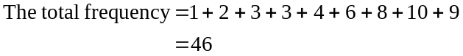
The data was recorded on 46 days.
The answer is B.

Question 2

The median is the middle score. There are 46 scores. Counting in from either end, the 23rd and 24th scores occur in the 35-40 range. So this is where the median lies. Alternatively, the median is located at the 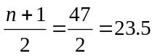th position.
The answer is D.

Question 3

The 68 – 95 – 99.7% rule applies to data which is bell shaped. This data is negatively skewed, and hence cannot be bell shaped.
The answer is C.

Question 4

Enter the data into your calculator and find the 1-Var stats. The standard deviation is closest to 15.
The answer is A.

Question 5

There were 383 people surveyed who were 30 and under. Of these, 116 had a car loan. This represents a percentage of 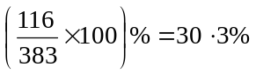. (to 1 decimal place)
The answer is E.

Question 6

If Tom’s argument is correct then we would expect that the percentage of people under 30 to have a particular type of loan would be different to the percentage of people over 30 who have the same type of loan. The statement in option A indicates this is the case for personal loans and hence it supports Tom’s argument.
The answer is A.

Question 7

The range is the difference between the highest and lowest scores, that is 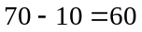.
The interquartile range is the difference between the right hand end of the box and the left hand end, that is 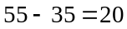.
The median is indicated by the line in the box, that is, 50.
The answer is D.

Question 8

Because the distribution is bell-shaped, we can use the 68 – 95 – 99.7% rule. Now 3.4 is 2 standard deviations below the mean (ie. 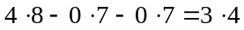). We know that 95% of the data lies 2 standard deviations either side of the mean. So 5% of data is greater than or less than two standard deviations from the mean.
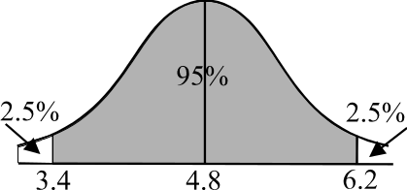
Because of the symmetry of the bell-shaped distribution,
2.5% of data is therefore less than two standard
deviations below the mean.
The answer is B.

Question 9

Movements that are repeated in the overall trend are referred to as cycles. Seasonal trends have a period of 1 year so we cannot have options A or D.
Option B has a cycle with a period of about 2 years.
Options C and E show no repetitive movements.
The answer is B.

Question 10

The data has been divided successfully, that is, there are 13 pieces of data. There should be 4 pieces in each of the left and right hand groups of data and 5 in the middle. George got this right.
Check the 3 medians. Remember to find the median of the x-values and the median of the y-values separately. There is a mistake in the group of data in the middle. The y-median was correct but the x-median was too far to the left.
The answer is C.

Question 11

Options A, C, D and E all have a pre-requisite that the relationship is linear. To first discover that, a scatterplot should be drawn.
The answer is B.

Question 12

Use your calculator to find the least squares regression line. The independent variable is the amount of water applied to the seed and the dependent variable is the number of days taken to germinate.
The answer is E.

Question 13

The coefficient of determination,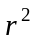, is equal to 0.7438. (Use your calculator to calculate this.) So, this means that 74% of the variation in the number of days taken to germinate could be explained by the variation in the amount of water applied per day. The remaining 26% could be accounted for by other factors.
Note that option C is incorrect since even though there might be strong correlation between two variables we cannot say that variation in one caused variation in the other. Option B is not appropriate since whilst there is negative correlation, the coefficient of determination,, does not tell us that, but rather Pearson’s correlation coefficient r tells us that.
The answer is D.

Module 1: Number patterns and applications

Question 1

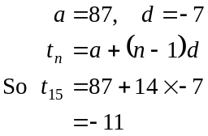
The answer is A.

Question 2

We notice that 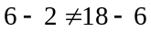 so we do not have an arithmetic sequence. However 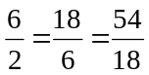, so we have a geometric sequence where 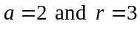.
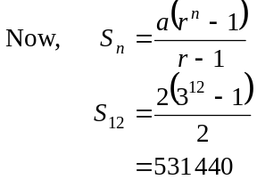
The answer is E.

Question 3

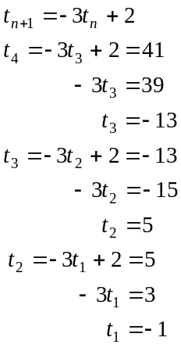
The answer is C.

Question 4

The sequence generated by the difference equation
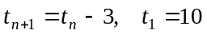
is an arithmetic sequence since there is a constant difference of 3 between each successive term.
Since 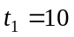, then equivalently 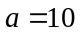 and since 3 is subtracted from each term to create the next term, then 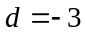.
We have, 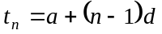
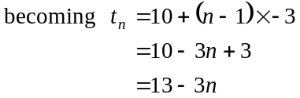
The answer is B.

Question 5

Clearly there is an increase in production. The amount the production increased each year however is the same. Hence the dots follow a straight line on the graph.
The answer is D.

Question 6

There were 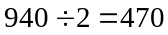 girls at the school.
In Year 12 the ratio of boys to girls is 4:5. There are 48 Year 12 boys so there must be 60 Year 12 girls (1 part represents 12 students). So there must be 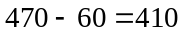 girls in Years
7 – 11.
The answer is C.

Question 7

The company profits each year form a geometric sequence. With 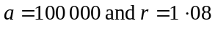. If 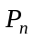 represents the annual profit of the company after n years, then
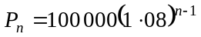
When 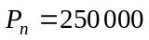, we have
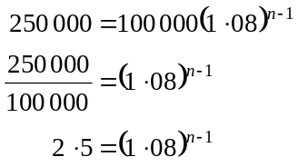

Method 1 - logarithms
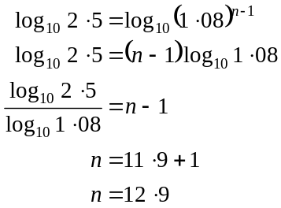
So after 13 years the profit would be forecast to exceed $250 000.

Method 2 - trial and error
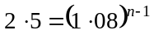
Try 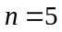 right side 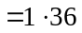
Try 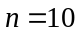 right side 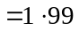
Try 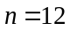 right side 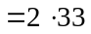
Try 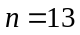 right side 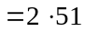
So after 13 years the profit would be forecast to exceed $250 000.
The answer is B.

Question 8

Sophie pays 6.2% on the balance of the loan. So, if 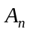 is the amount that Sophie owes at the start of the n th year then she has to add on 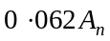 in interest. She reduces what she owes by $7500 each year however. So, at the start of the 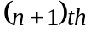 year she owes.
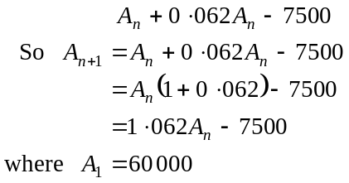
The answer is C.

Question 9

The ball follows the following motion shown below:

↓
1.2m
 | ↑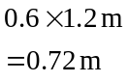 | ↓  0.72m | ↑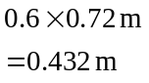 | ↓  0.432 m

The total distance it would travel is
The bracket is an infinite sum of a geometric sequence with a = 0.72 and r = 0.6.
So, total distance travelled
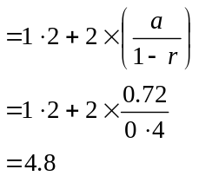
The answer is B.

Module 2: Geometry and trigonometry

Question 1

Since 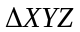 is a right-angled triangle,
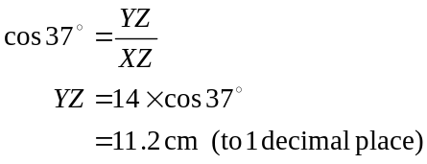
The answer is D.

Question 2
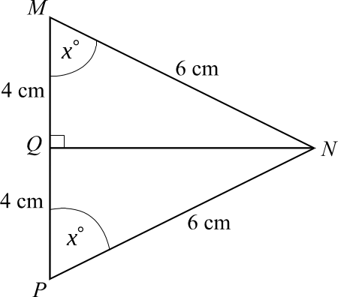

Since ΔMNP is isosceles, 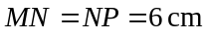. Construct NQ which bisects 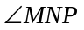 and meets MP at right angles so that 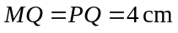.
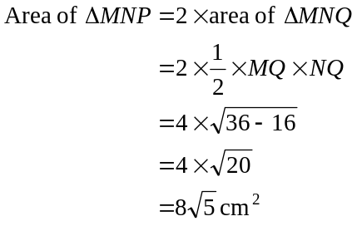
The answer is C.

Question 3
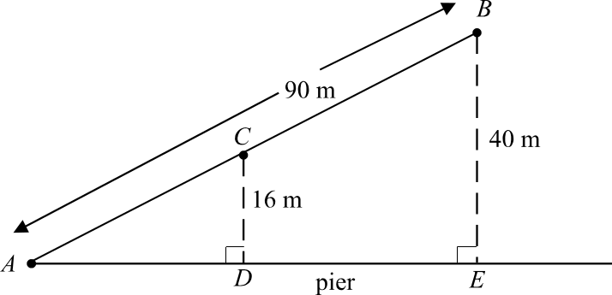

Since ΔACD and ΔABE are similar,
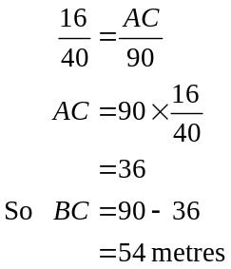
The answer is D.

Question 4
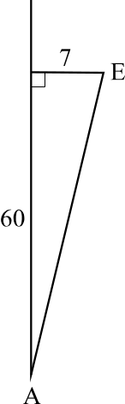
The distance along AB between point A and the
perpendicular offset to point E is
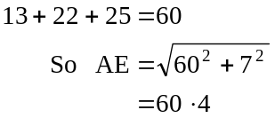
(to 1 decimal place)
The answer is E.

Question 5
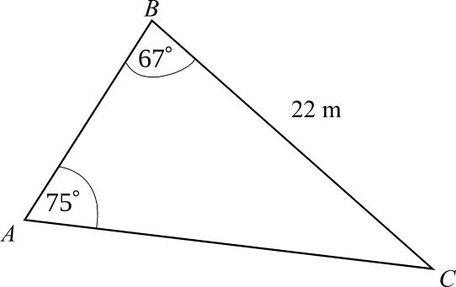
In ΔABC,
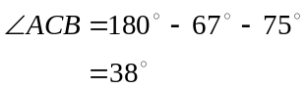
So,
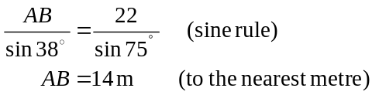
The answer is A.

Question 6

In ΔBCD, 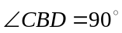
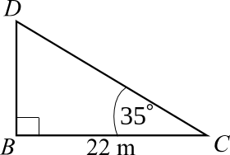
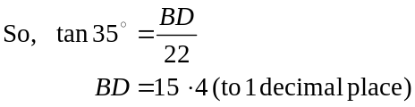
So the height of the pole is 15.4 metres (to 1 decimal place).
The answer is B.

Question 7

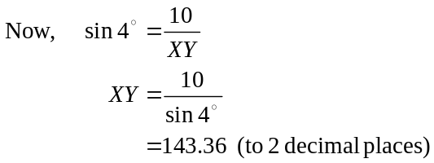
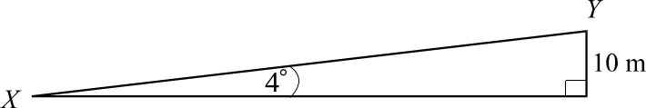
The closest answer is 143 m.
The answer is E.

Question 8

Since the small and large containers are similar in shape, then
the volume of large container 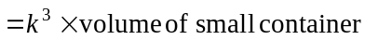where k is the scale factor relating the linear dimensions (like height) of the two containers.
We are told that the volume of large container is .
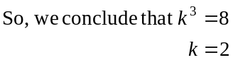
So if the height of the small container is 7 cm then the height of the large container is 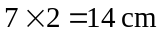.
The answer is A.

Question 9
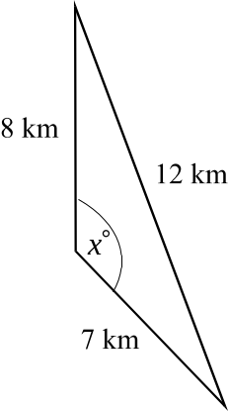
Draw a diagram.
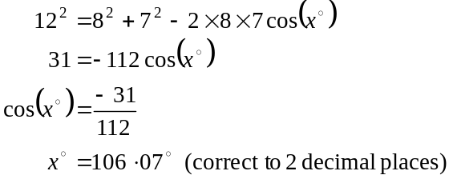
The value of x to the nearest degree is 106.
The answer is D.

Module 3: Graphs and relations

Question 1

The graph passes through points 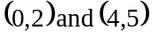.
The gradient is
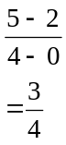
The equation is given by
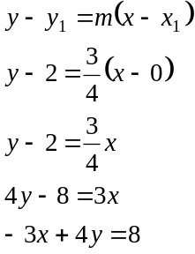
The answer is C.

Question 2

At 10.20 the saturation is at 97% and falls below that for a period of about 15 minutes. At about 10.45 the saturation is again at about 97% and falls below this until about 10.55.
So the oxygen saturation was below 97% for approximately 25 minutes.
The answer is C.

Question 3

The rule that describes the graph is given by Option E. Note that all the upper endpoints are included and all the lower endpoints are excluded.
The answer is E.

Question 4

The equation of the diagonal line is 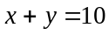 since when 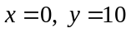 and when 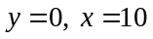. The equation of the horizontal border is 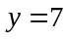. The equation of the vertical border is 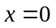. The shaded region with boundaries included is given by
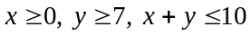.
The answer is C.

Question 5

There are three corner points of the feasible region.
At 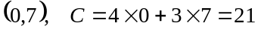
At 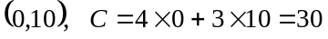
At 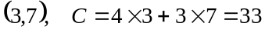
The answer is A.

Question 6

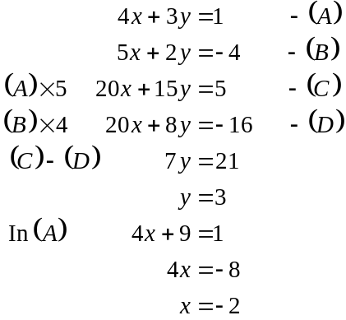
The solution is 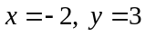.
The answer is A.

Question 7

The graph is a straight line showing y versus 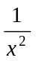.
The rule is of the form.
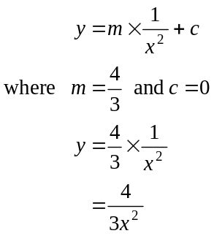
The answer is B.

Question 8

Carmel always has a drink that costs $1. So the intercept on the vertical axis is 1. Each “bite” ordered by Carmel costs $1 and so the gradient of the line is 1.
Similarly, for Patrick the intercept on the vertical axis is 3 and the gradient is 0.5. Carmel’s line is therefore steeper than Patrick’s line since 1>0.5.
The correct graph is given by D.
The answer is D.

Question 9

Each bicycle can deliver 20 document satchels per trip and so, in a day, each bicycle can deliver 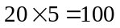 document satchels.
Similarly, each day, each motorcycle can deliver 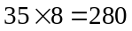 document satchels.
The constraint therefore is 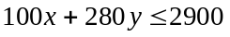.
The answer is D.

Module 4: Business-related mathematics
Question 1
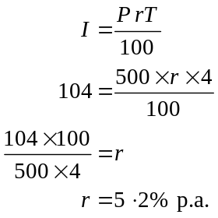
The answer is A.

Question 2
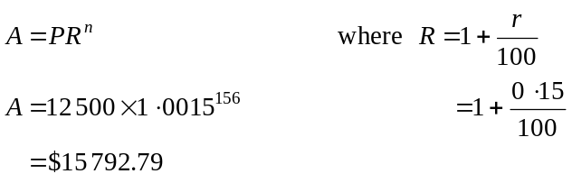
Note that the period is 1 week so the interest rate per period, r, is equal to 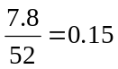. Also there are 52 periods per year and the investment is for 3 years so 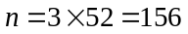.
The answer is C.

Question 3

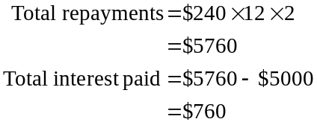
The answer is B.

Question 4

The effective rate of interest is approximately equal to 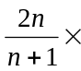 flat rate per annum.
The flat rate of interest per annum
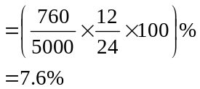
So the effective rate of interest is
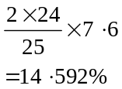
The answer is B.

Question 5
Stuart will make 6 repayments of $3 827.67, which is a total of $22 966.02. So, the total amount of interest is $22 966.02 - $20 000 = $2 966.02.
The answer is A.

Question 6
According to the reducing balance method of depreciation the machinery reduces in value each year by a fixed percentage. Hence the value decreases each year by a decreasing amount. The graph, which shows this, is graph E.
The answer is E.

Question 7

We need to use the annuity formula since a regular repayment is to be made.
Now, 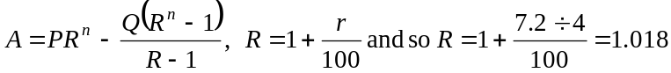
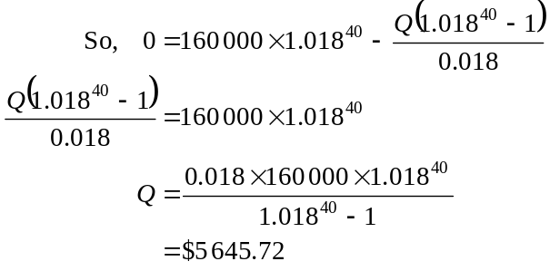
The answer is C.

Question 8

Interest per annum is 3.6%.
Interest per month is 0.3%.
The minimum monthly balance for –
January is $972.63
February is $622.63
March is $1272.63
The interest paid this quarter is
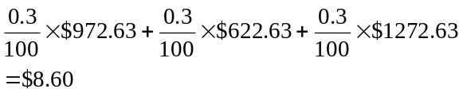
The answer is A.

Question 9

Let x be the amount invested by Tom and by Ciara.
The amount in Tom’s account after 5 years is 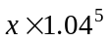.
The amount of interest earned by Tom after 5 years is
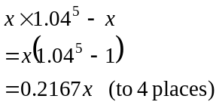
The amount of interest earned by Ciara after 5 years is
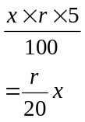
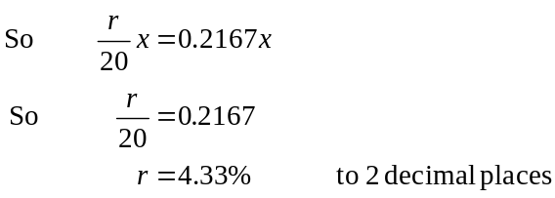
The answer is A.

Module 5: Network and decision mathematics

Question 1
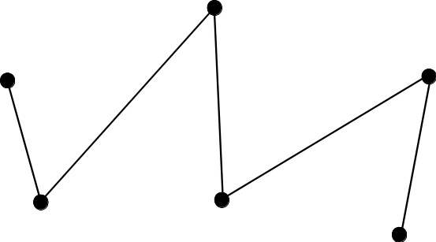

The minimum number of edges required for this graph to be connected is 5 since a connected graph has a path from any point to any other point on the graph.
The answer is C.

Question 2

The path starts at B and finishes at A so it is not a circuit. The path visits each vertex just once so it is an Hamiltonian line.
The answer is D.

Question 3

Since we have a connected planar graph, we use Euler’s formula.
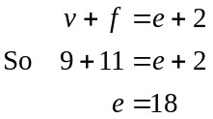
The answer is C.

Question 4

The incorrect alternative is E since Paul and Kelly each has two preferences. All the others are true.
The answer is E.

Question 5
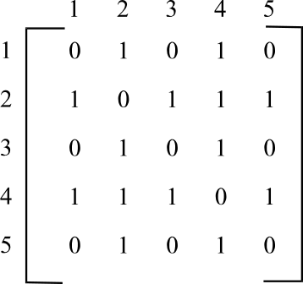

There is an edge between
1 and 2 and hence 2 and 1
2 and 3 and hence 3 and 2
3 and 4 and hence 4 and 3
2 and 4 and hence 4 and 2
2 and 5 and hence 5 and 2
1 and 4 and hence 4 and 1
and between 4 and 5 and hence 5 and 4

The answer is B.

Question 6

The minimum spanning tree is shown below.
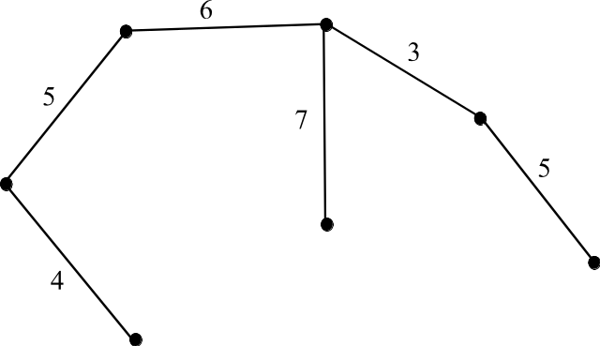

The total weight on this tree is 30.
The answer is B.

Question 7

Using the Hungarian algorithm we obtain:
 | A | B | C | D
Kate | 2 | 4 | 5 | 5
Piv | 3 | 3 | 7 | 6
Kiran | 4 | 6 | 6 | 3
Eric | 4 | 3 | 2 | 3
Step 1 – subtract the minimum number in each row from the other numbers in that row.
 | A | B | C | D
Kate | 0 | 2 | 3 | 3
Piv | 0 | 0 | 4 | 3
Kiran | 1 | 3 | 3 | 0
Eric | 2 | 1 | 0 | 1
Step 2 – Rows 1, 3 and 4 contain only 1 zero. Box them and cross out the other zeros in the column.
 | A | B | C | D
Kate | 0 | 2 | 3 | 3
Piv | 0 | 0 | 4 | 3
Kiran | 1 | 3 | 3 | 0
Eric | 2 | 1 | 0 | 1
The allocation is completed.
The manager should
assign Kate to project A
assign Piv to project B
assign Kiran to project D
assign Eric to project C
The answer is C.

Question 8
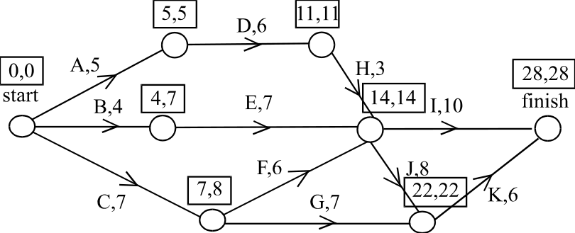

Above each of the nodes, are written the earliest start time and the latest start time.
The critical path is A, D, H, J, K.
The minimum time taken to complete the management project is 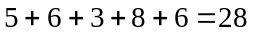 weeks.
The answer is E.

Question 9

It doesn’t matter what the capacity of arc EF is since the arc flows from J to A across the cut. We therefore don’t count the capacity on that arc – we ignore it. The capacity on the other 5 arcs, which do flow from A to J, must add to give 33. So the capacity on arc DG is 9.
The only possible answer is E.
The answer is E.

